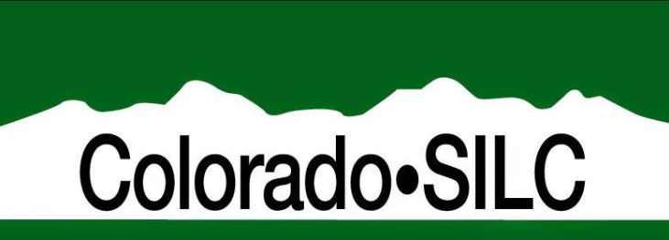
Meet and Greet
Tuesday, March 14, 2017
5:30 PM – 7:00 PM
Pinewood Community Club House
399 Amethyst Ave, Loveland, CO

General Meeting
Wednesday, March 15, 2017 www.coloradosilc.org 303-902-5897
8:30 AM – 4:30 PM coordinator@coloradosilc.org
Residence Inn, Trail Ridge Room
5450 McWhinney Blvd.
Loveland, CO

Online video conferencing: Join from PC, Mac, Linux, iOS or Android: https://zoom.us/j/660156791

ASL Interpreters: Christine Pendley and Amber Roseborough

AGENDA for Wednesday 3/15/2015

8:30 Call to Order (Joe)
- Introductions
- Approval of Agenda
- Approval of the minutes
- Chair Person remarks (Joe)

9:00 Bob Williams & Deb Cotter, ACL/ILA

10:05 Peter Pike, Office of Independent Living

10:15 Break

10:30 Old Business
- 704 Report presentation (Karen)
- Ops guide and By-laws revisited (Joe)
- Committee assignments and composition (Joe)
- CIL Adoption program assignments

11:00 Youth Leadership SPIL Goals (Bill Wood and Melissa Santora)
- AYLF (APRIL Mentoring program)
Working
Lunch
- YAC (certificate program)
- Intern Program
- Youth Transitions Conference 4/18-20

12:45 Break

1:00 Public Comment (Sign-up sheet by the door)

1:20 Committee Updates
- Executive (Joe) (4/17 added meeting)

Standing Committee Updates

    - Finance (Martha)
    - Public Policy (Jennifer) (Capital Watch)
    - Membership (Joe)
    - SPIL (Chris
    - Youth (Bill)

Ad Hoc Committee Updates

    - Communications - Website/Social Media (Joe)
- 501 C-3 (Joe)
- Retreat Committee (Joe)
- SILC Coordinator workgroup (Joe)

2:20 SRC Report (Melissa/Joe) (Employment First)

DVR Report (Jennifer)

121 report (Travis)

2:45 Break

3:00 Center’s Director’s Report (Nancy)

3:30 Conferences and Trainings (Select attendees)
- Youth Transition Nat’l Conference Denver Westin 4/18-20
- National ADA Symposium, May 14-17, Chicago
- NCIL; July 23-28, 2017 Washington DC

3:45 New Business
- Mapping Program update
- Employment Diversity Symposium
- Meet & Greet assignment: May, June, July, Sept (Joe)

4:00 SPIL update and Strategic Planning day (Bill/Chris/Martha)
- Super Calendar maintenance
- Goal activity update and forecast for May
- Deaf and HOH program (office of sign language services, 20 agencies listening session)
- Tightening up Goal activities to objectives and budget
- 4/17 Strategic Planning and SPIL update day

4:30 Member feedback loop, close and Adjourn meeting

